ATTN: Local Newsletters/Enews/Websites/Social Media
SUBJECT: MSEA Convention 2015
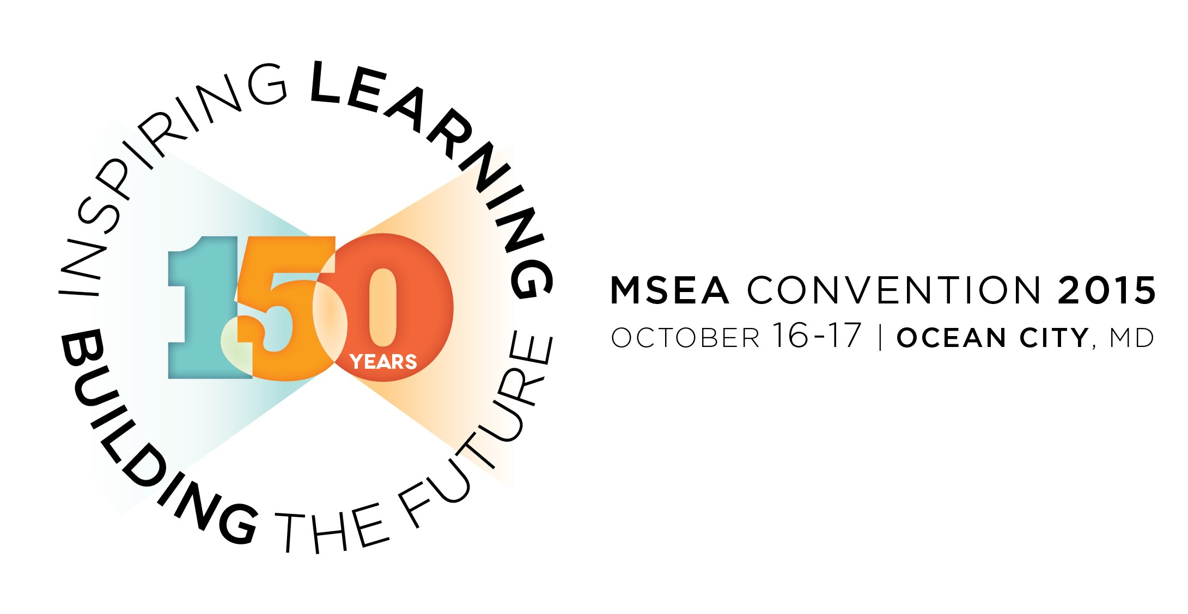

Inspire Learning—FREE Workshops Plus Special Program
Open to All
- 32 workshops help you build your professional practice, inspire student success, and strengthen the social and emotional health of your classroom and school communities.
- Special Friday session on Restorative Practices Learn how a fresh approach to discipline and atmosphere helps students and school communities grow and learn.
Build the Future of Our Association
600+ Delegates Elected by YOU to Represent YOU
- At MSEA’s 148th Representative Assembly more than 600 delegates elected by members from across the state discuss, debate, and vote on MSEA’s activities, policies, and programs.
- President Betty Weller welcomes special guest U.S. Secretary of Labor Tom Perez
- With 13 bylaw amendments on tap as well as several special elections and new business items, delegates will be busy guiding MSEA to a strong future.
There’s More …
- Get the MSEA Convention app! Visit marylandeducators.org/Convention for more.
- Don’t miss the kick off Thursday night, with a networking reception at 6:45 p.m. in the Convention Center followed by MSEA’s Got Talent at 7:30 p.m. in the brand-new Performing Arts Center. Learn more and submit your talent at marylandeducators.org/Convention before September 18!
- Check with your local president to make sure you’ve got your ticket to Seacrets, the best party in town on Friday, October 16. MSEA takes over Ocean City’s most famous nightspot for a night of fun!
- Education vendors, MSEA’s Member Trade Show, and Apple-a-Day Health Fair

Don’t miss it—October 16 & 17 at the Roland E. Powell Convention Center in Ocean City! Visit marylandeducators.org/Convention regularly for details, including a full workshop schedule, presenter bios, details on special events, and much more.

